1.

Null hypothesis: True mean is less than 19

Alternative hypothesis: True mean is greater than 19

p-value is significantly less than the alpha, there is enough evidence to reject the null hypothesis and support the alternative hypothesis which is “True mean is greater than 19”.

2.

Null hypothesis: male students are on average shorter than female students.

Alternative hypothesis: male students are on average taller than female students.

p-value is less than alpha, there is enough evidence to reject the null hypothesis and support the alternative hypothesis which is “male students are on average taller than female students”.

3.

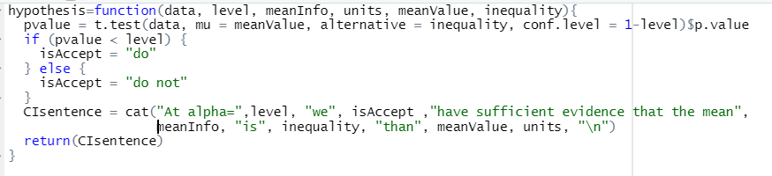



4.

